**CS5551: Advanced Software Engineering**

**Spring 2015**

**Project Increment-III (PG-9)**

**Project Title: Virtual Learning**

**Submitted By:**

Teja Mosali (Class Id: 34)

Tejaswini Nalamotu (Class Id: 35)

Bala Sai Teja Gaddam (Class Id: 15)

Manisha Kattukuri (Class Id: 27)

1. **Objectives:**

Education is the most prominent tool for enhancing skills and capabilities in the area in which they want. In earlier days exams are used to be much dependent on paper based but now-a-days everything has become online. Hence, most of the examinations are held in online. In order to follow the current trend of organizing examinations, we are developing the application called Virtual Learning. In this application, the information of the tutors are provided. Time management is the major aspect which can be provided through our application Virtual Learning.

1. **Import Existing Service/APIs:**

Visual Studio has been used as an Integrated Development Environment in our application. We are providing various kinds of functionalities with the help of Application Programming Interfaces (APIs). The Master page is the key for all the other pages. CSS is used for styling of the Master page. Every page will be directed from the Master page itself i.e., all the pages must be inherited from the Master page.

**Bootstrap:**

Bootstrap has been used in our ASP.NET project to provide responsive HTML5 forms which makes forms to appear very fast and makes it light weight. We have downloaded Bootstrap and JQuery and included in our application. This had different CSS, Fonts and Script folders which helped in accessing bootstrap classes which provided different styles and animations to the page. The master page, home page and contact page have been completely designed using different bootstrap classes such as “navbar”, “animated fade”, “btn btn-common btn-lg”, font awesome icons which provide different icons and can be used by including “fa fa-icon name”. The complete look and feel of the web forms has been changed with the usage of the Bootstrap.

**Google Search API:**

This Google search Application Program Interface is used by the students to search the topics in which they are lagging. We will get all the features which are included in the google search engine. Our search bar acts as the google search bar in google website.

**Barcode:**

Barcode is a feature in which each student is assigned with a unique code which upon scanning will display the student id. We are also trying to extend this feature so that it can display the students overall participation in the tests conducted and also to show the results of each test. Here we used code39 type of barcode. In this code39 barcode can be generated by using letters or digits or both. We can also include special characters like -, $, / etc., in that barcode. In code39 the barcode starts with star and ends with star which is called delimiters. These are used to indicate start and stop of the word. By using barcode scanner we will get the word but not the stars included in it.

**Yahoo search API:**

This Yahoo search Application Program Interface is used by the students to get the information regarding the people of their interest. If a student want to communicate with a tutor or person who are available in internet, then he/she can use yahoo interface and find his details. It acts as yahoo search bar in yahoo website.

**Google Maps:**

In our application we are going to include Google Maps so that it can display the Tutor’s location which we are going to provide. We have extracted the Key for Google MAP API from Google Developer Console.

1. **Detail Design of Services:**
2. **User stories:**

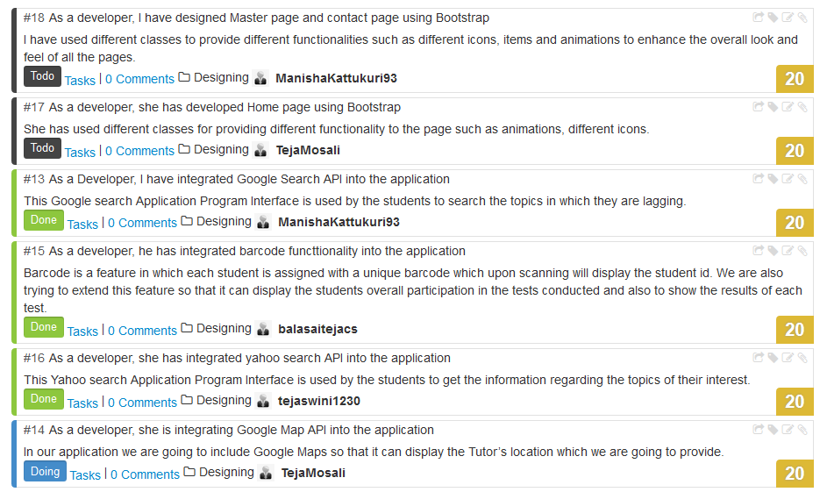

1. **Service Description:**

With the help of Visual Studio .Net applications are created. ASP.NET web services can be understood easily. ASP.NET is used for developing the web applications as well as services. HTT and XML are the technologies used for some web protocols. ASP.NET web form templates are used for the generation of web applications and this provide the functionalities such as,

* Navigation by using menu control
* Home page
* CSS
* Security with ASP.NET
* JQuery with the help of Ajax scripting

The default features by the template,

* Master page
* Package configuration file
* CSS files in addition with membership pages and client script files are embedded in a folder.
* Web configuration file
* Global application class

1. **Sequence Diagram:**

**Admin:**



**Student:**



1. **Class Diagram:**

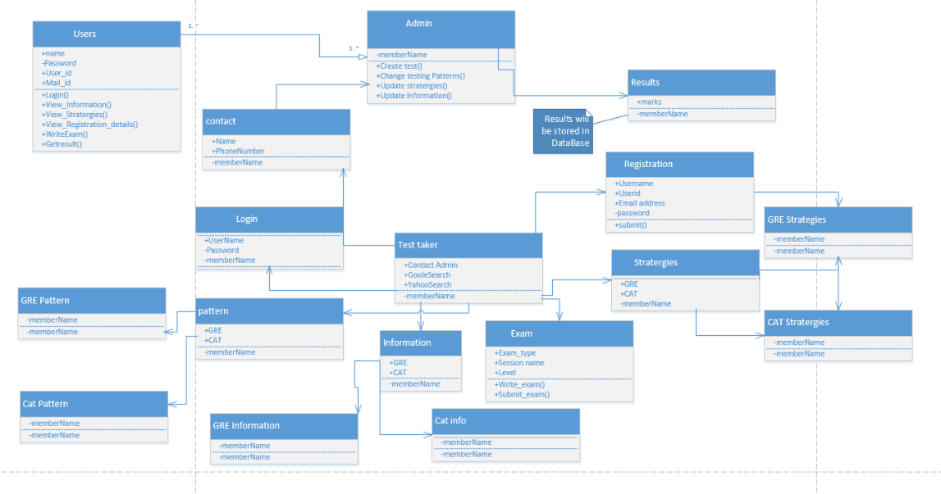

1. **Screenshots and Explanation:**
2. **Master Page:**

Master page is the major part of our application. Through the master page each and every page is directed and modules are also depends on the master page. This page consists of several modules such as user registration, login page, information, pattern, strategies, registration details, mock tests and we are also trying to include tutor information page. Bootstrap theme was also included in the master page in order to have good look and feel. Barcode feature is included in the master page to give each user a unique id.



1. **User Registration Page:**

If any user is accessing this application for the first time, they need to register themselves into the application first in order to use the application. For the registration process, they need to give all the credentials provided accurately. Then those credentials will be updated into the database provided for the application. If any credential is not given at the time of registration, then an error message is displayed. After registration is completed then they can login into the application with those credentials.

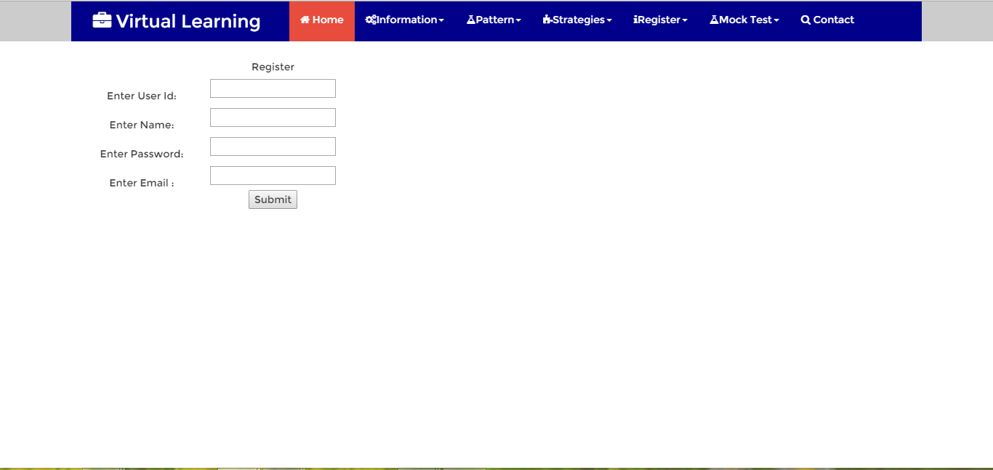

1. **User Login Page:**

Once the registration process is completed, user can log into the application with the help of the user login page. User needs to give the appropriate credentials for the login page in order gain the access of application, otherwise an error message will be displayed and user cannot be able to use the application. Once user logs into the application, they can view the overall information regarding the GRE and CAT examinations, pattern and strategies for those exams, user can take mock tests, view the information regarding the tutors who are giving training in the fields required for those tests.

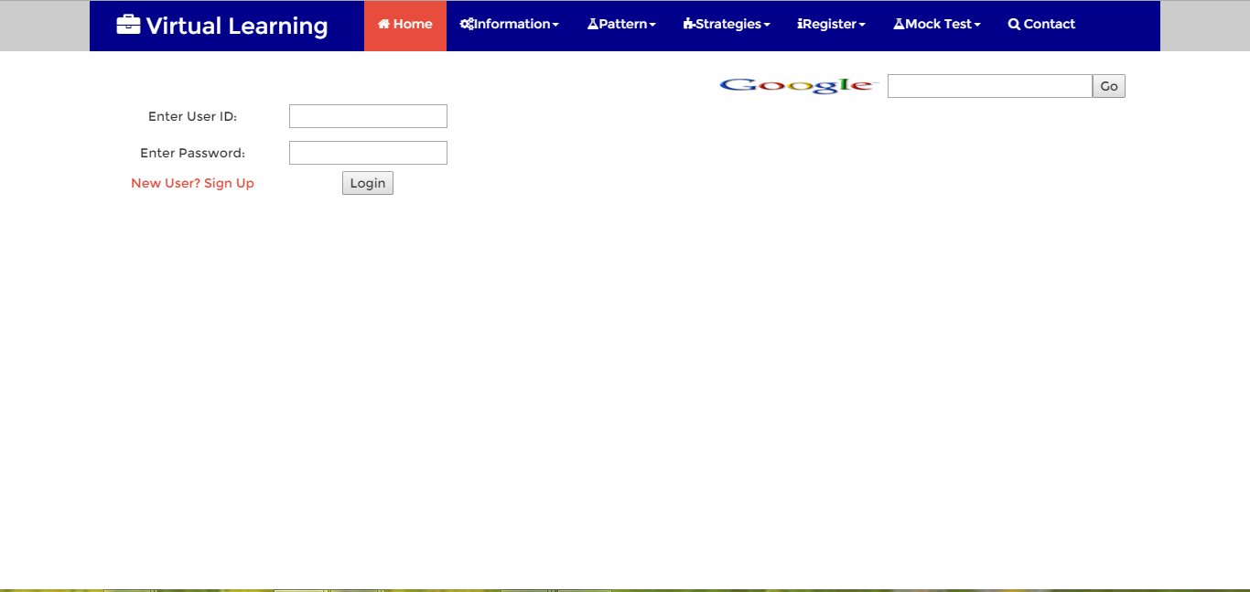

1. **Information Page:**

The information page gives the knowledge of the exams (GRE and CAT) by giving the overall information about those exams. This page provides the user about the topics which are going to be tested, so that user gets the basic knowledge of what topics are going to be covered in the exam.

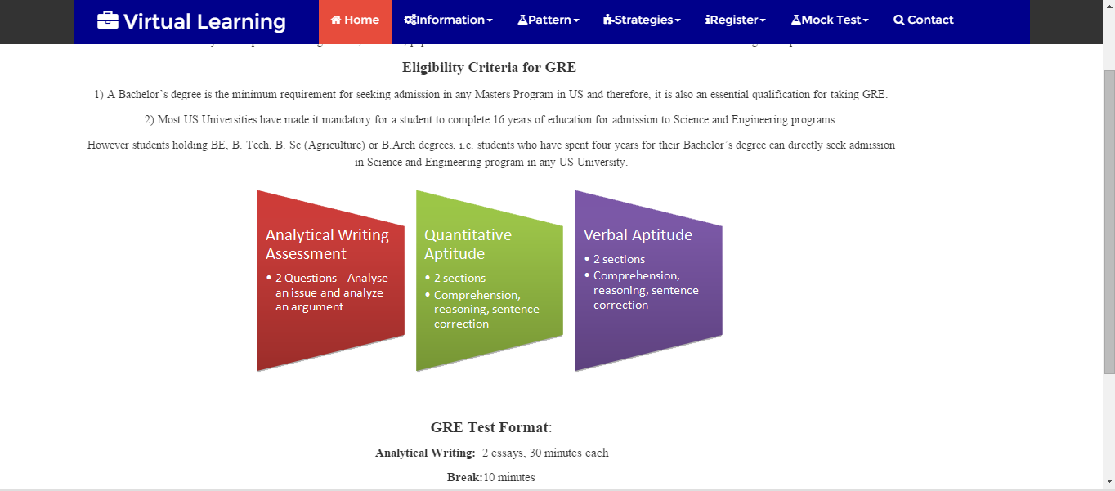



1. **Pattern:**

Knowing the pattern of the exam is the foremost thing for the success of that exam. The pattern page serves this basic need to write the tests effectively. We have given pattern for both GRE as well as CAT in this page which includes time for the test, sections and marks allotted each section in detail.

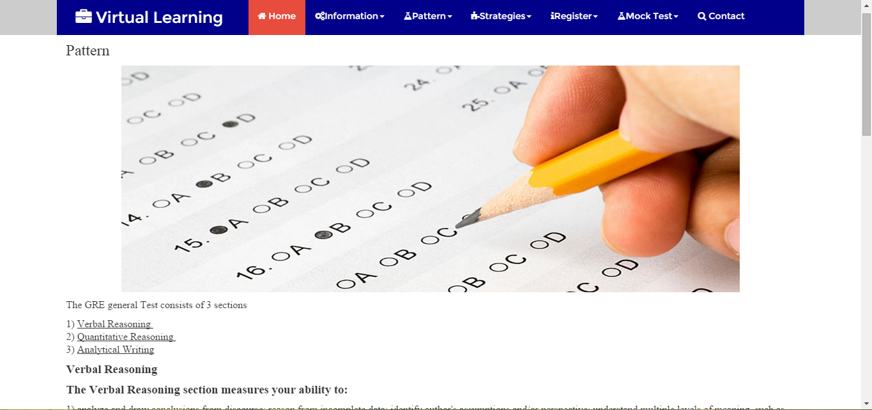

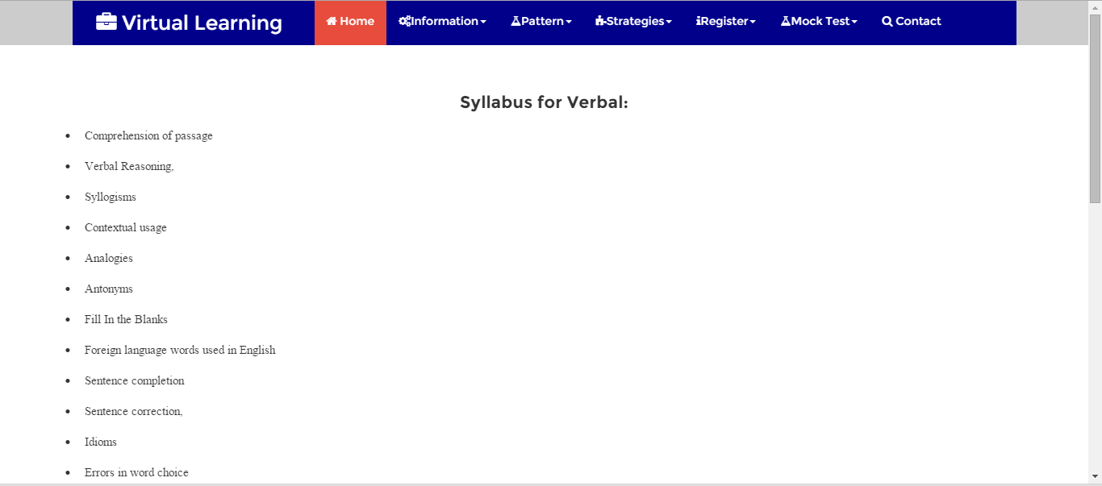

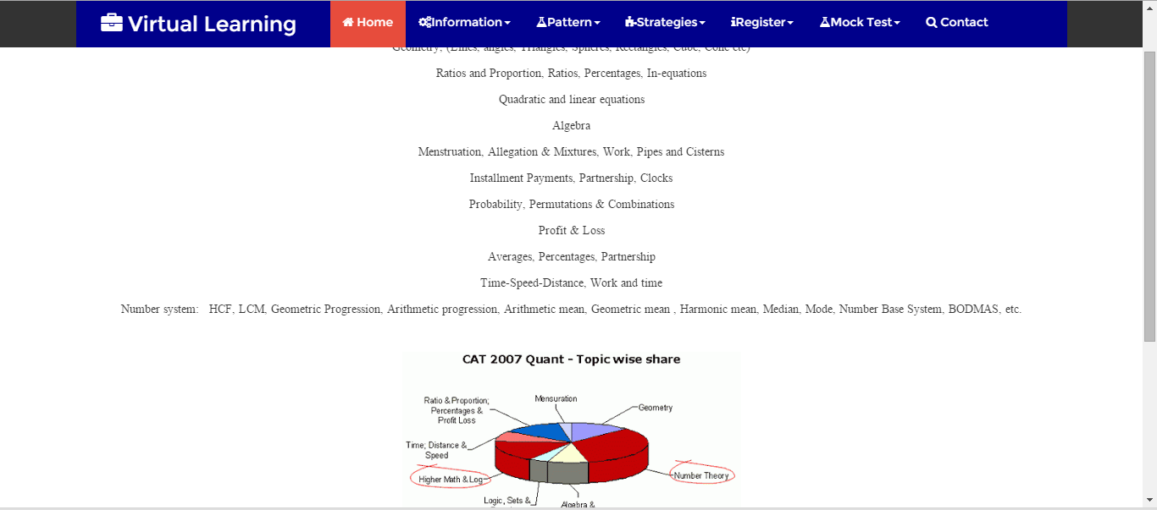

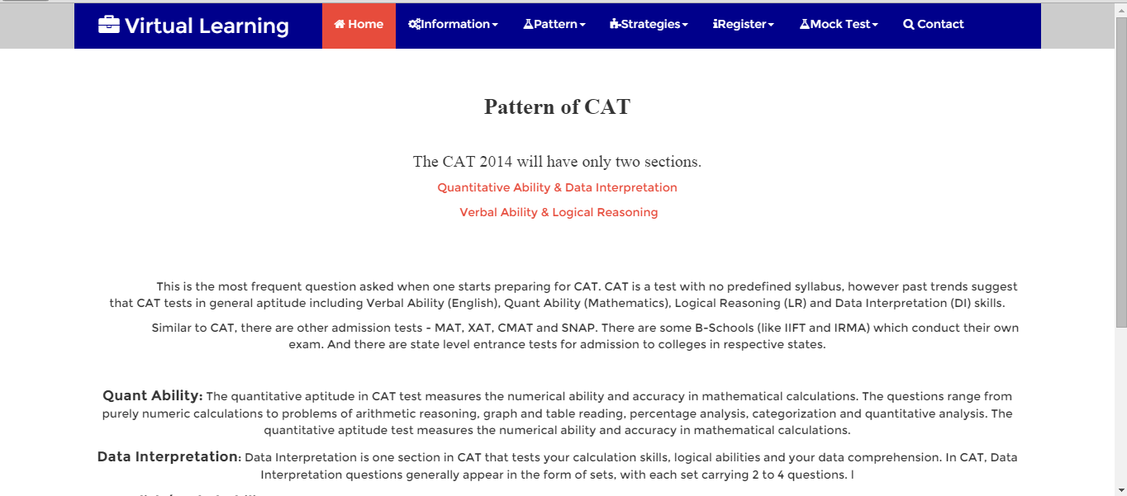

1. **Strategies:**

Student need to follow the strategies in order to get improved results. The strategies page provides strategies for both GRE and CAT which can improve the performance of the users who are taking the exams. Different strategies are employed for both GRE as well as CAT.

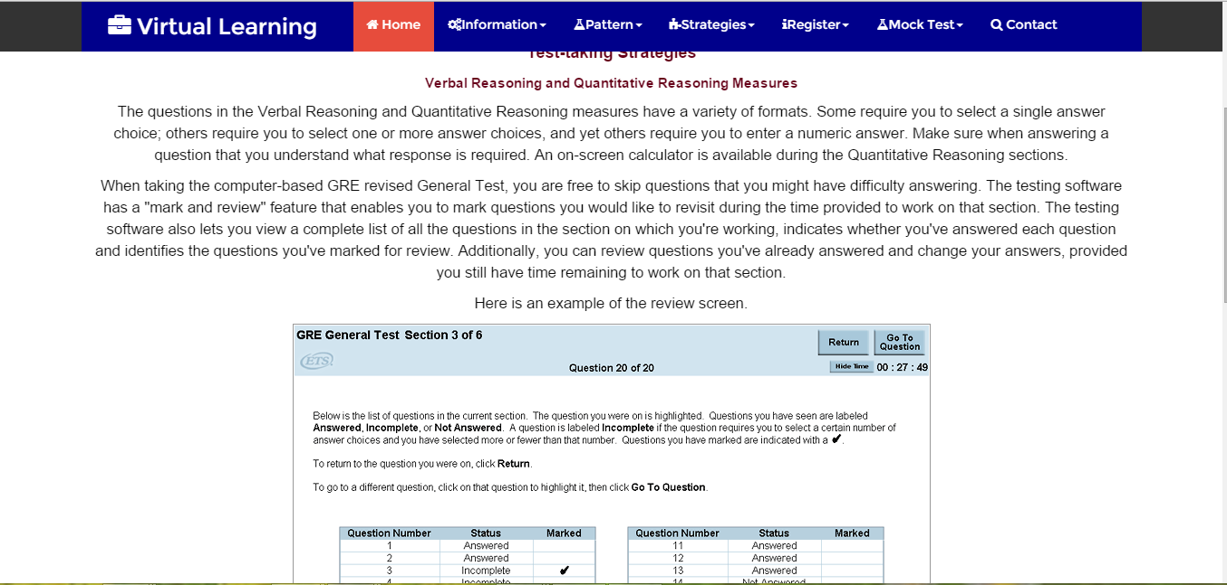

1. **Registrations Details:**

Prior to any test registering for that test is must. In this registration page we have included the registration details of the original GRE and CAT tests which are conducted internationally by ETS website. Registration details include the amount to take test, when exam is conducted and where it is conducted.

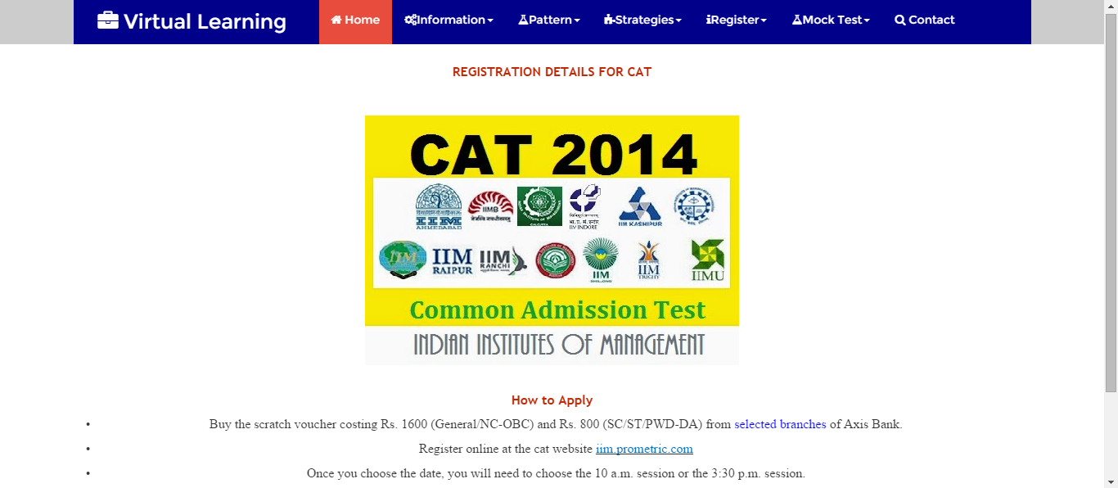

1. **Mock Test:**

Tests are conducted in order to evaluate the student performance on a particular area. If the student attends the mock test before he takes up the real test, student can understand the drawbacks, in which particular are he is lacking and learns from the mistakes which student done in the mock test.

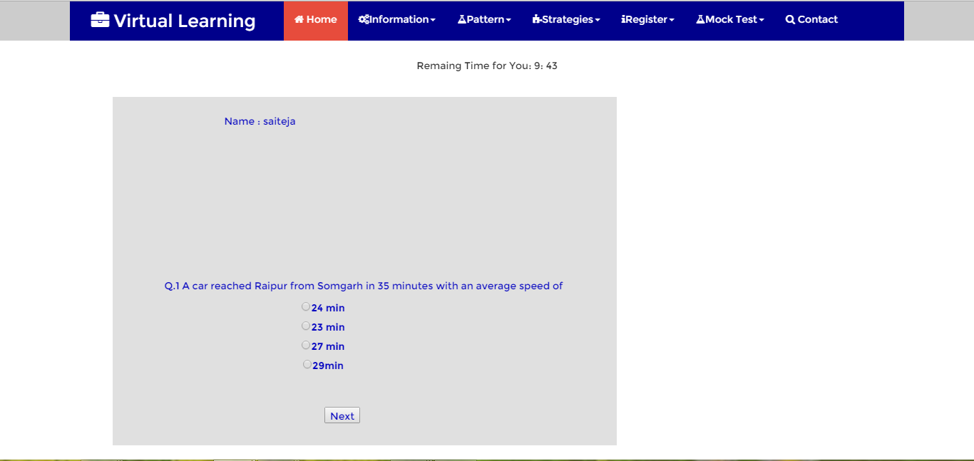

1. **Tutors:**

In this page of the application (Tutors) we are providing the Tutor’s information who are giving training in topics related to GRE and CAT. We are giving the addresses of those tutors and are trying to integrate the google maps to display the location of tutors.

1. **Contact Us:**

This page used by the user if they have any doubts and wants to contact the application provider.

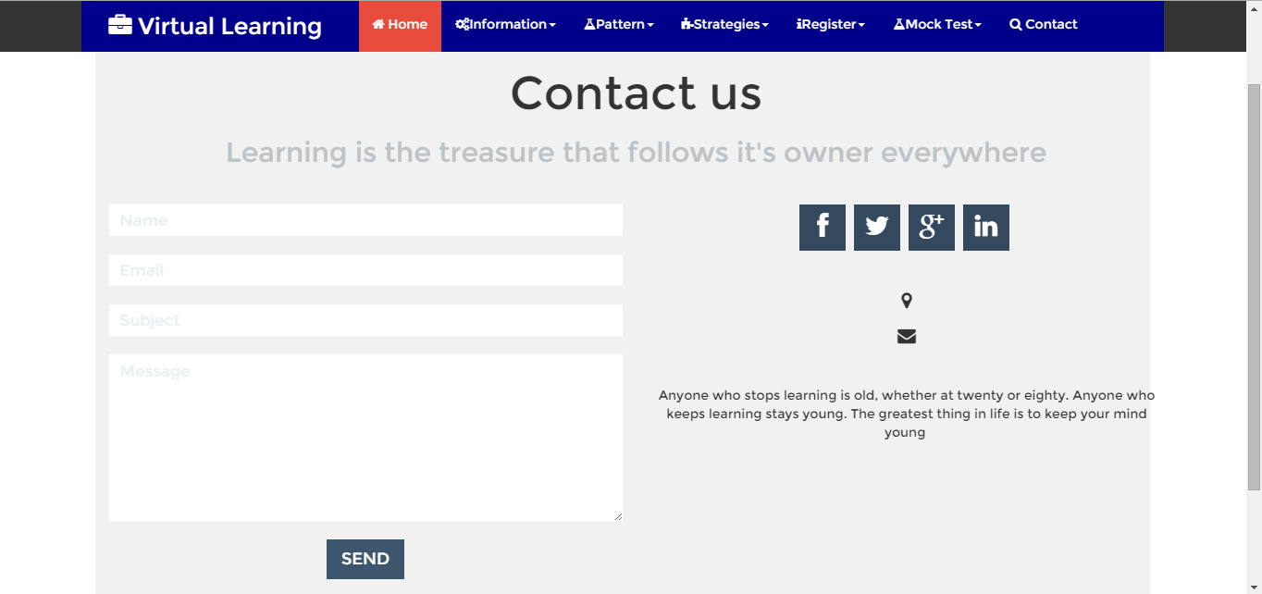

1. **Testing:**
2. **Google Chrome:**



We calculated the time taken to run our project in Google chrome several times. The average time taken to run our project in Google chrome is 1.57 sec(which was taken to display the home page). To traverse from one web form to other web form in Google chrome, it took an average time of 0.55 sec. We calculated the time taken for each web form to other web form several times and took their average as a result. I also place the screen short when we use this browser to show the look and feel of our project.

The following are the results for time taken results for one of several times:

To open Home page: 1.57

GRE Information page: 0.52

CAT Information page: 0.46

GRE Pattern page: 0.45

CAT Pattern page: 0.49

GRE Strategies page: 0.45

CAT Strategies page: 0.44

GRE Register page: 0.47

CAT Register page: 0.43

Mock Test page: 0.54

1. **Internet Explorer:**



We calculated the time taken to run our project in Internet Explorer several times. The average time taken to run our project in Internet Explorer is 1.34 sec (which was taken to display the home page). To traverse from one web form to other web form in Internet Explorer, it took an average time of 0.56 sec. We calculated the time taken for each web form to other several times and took their average.

The following are the results for time taken results for one of several times:

To open Home page: 1.35

GRE Information page: 0.56

CAT Information page: 0.58

GRE Pattern page: 0.52

CAT Pattern page: 0.53

GRE Strategies page: 0.52

CAT Strategies page: 0.54

GRE Register page: 0.56

CAT Register page: 0.49

Mock Test page: 0.59

1. **Mozilla Firefox:**

We also calculated the time taken to run our project in Mozilla Firefox several times. The average time taken to run our project i.e., to display the home page is 1.52 sec. The average time taken to traverse from one web form to another web form is 0.55 sec.

1. **Safari:**

We also calculated the time taken to run our project in Safari several times. The average time taken to run our project i.e., to display the home page is 1.49 sec. The average time taken to traverse from one web form to another web form is 0.56 sec.

We tested with these four web browsers and we got these results. By analyzing all these results, we can conclude that Internet Explorer took less time when compared with other browsers like Google chrome.

1. **Deployment:**
2. **Scrum Do:**

[**https://www.scrumdo.com/projects/project/virtual-learning1/iteration/126326**](https://www.scrumdo.com/projects/project/virtual-learning1/iteration/126326)

1. **Project URLs:**

[**http://localhost:4814/Login.aspx**](http://localhost:4814/Login.aspx)

[**http://localhost:4814/FinalTest.aspx**](http://localhost:4814/FinalTest.aspx)

[**http://localhost:4814/GREPattern.aspx**](http://localhost:4814/GREPattern.aspx)

[**http://localhost:4814/CATPattern.aspx**](http://localhost:4814/CATPattern.aspx)

[**http://localhost:4814/GREInfo.aspx**](http://localhost:4814/GREInfo.aspx)